Driving Question: Can words lead to war?

Adapted excerpt from Uncle Tom’s Cabin, Chapter 30.

Summary:
At a slave auction house, Uncle Tom is sold to a cruel master named Simon Legree. Another slave, Susan, is separated from her daughter, Emmeline, when they are sold to different masters.

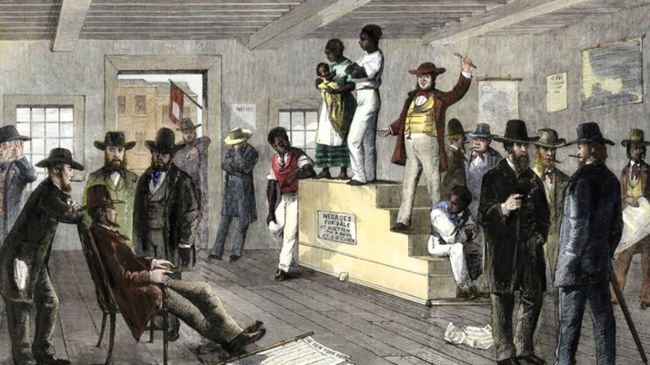
Tom hardly saw or heard anything; but still the bidding went on. Down goes the hammer again,—Susan is sold! She goes down from the block, stops, looks back,—her daughter reaches for her. She looks with agony at the man who has bought her,—a middle-aged man, with a kind face.
cruel – mean
master – owner
separated – taken away (from); stop being together
bidding - the act of offering to pay a certain amount of money for something
agony – pain; suffering
frightened – scared
timid – shy
afford – have enough money
“O, Mas’r, please buy my daughter!”
“I’d like to, but I can’t afford her!” he said, as her daughter, Emmeline, walked up on the block looking around with a frightened and timid look.
The auctioneer speaks in French and English, and bids go up quickly.
“I’ll try,” said Susan’s master, joining with the bids.
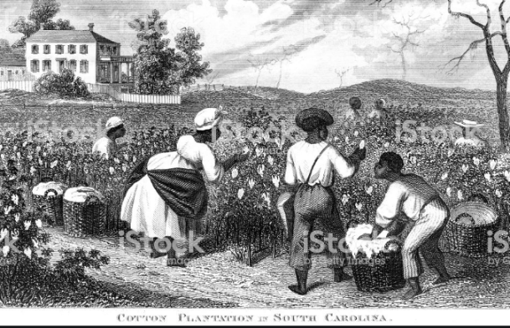
In a few moments, he cannot afford her daughter. It is now between an upper-class man and another man. The upper-class man bids a few more times; but the other man has more money; the hammer falls,—the other man has got the girl, body and soul! Emmeline’s master is Mr. Legree, who owns a cotton plantation. She is pushed into the same area with Tom and two other men, and goes off, crying. Susan’s master is sorry; but, this happens every day! One sees girls and mothers crying, at these sales, always! It can’t be helped. He walks off, with his purchase, in another direction.

Adapted excerpt from Fredrick Douglass’s July 5, 1852 Speech “What to the Slave is the Fourth of July?”

But, such is not the state of the case. I say it with a sad sense of the differences between us. I am not included within this glorious anniversary! Your high independence only reveals the immeasurable distance between us. The blessings in which you celebrate, are not enjoyed in common. — The inheritance of justice , liberty , and Independence , bequeathed by your fathers, is shared by you, not by me. The sunlight that brought life to you, has brought death to me. This Fourth [of] July is yours, not mine. You may rejoice, I must mourn. To drag a man in fetters into a temple of liberty, and ask him to join you in joyous songs, were mean and disrespectful. Do you mean, citizens, to mock me, by asking me to speak to-day? Let me warn you that it is dangerous to copy the example of a nation whose crimes, were thrown down by the Almighty, burying that nation in ruin! I can to-day talk of the great sadness and pain of these people!
reveals – shows; uncovers
immeasurable – very great in size or amount; huge
inheritance – money, property, etc. that is received from someone when that person dies
bequeath – left to another person; pass something on
rejoice – to feel or show happiness for something
mourn – to feel or show great sadness or unhappiness about something
fetters – chains placed around a person’s feet to restrict motion
mock – to laugh at or make fun of

 | Uncle Tom’s Cabin | Fredrick Douglass’ July 5, 1852 Speech
Details
What is the main idea in the passage?
What details (evidence) support the main idea?
Tone
What emotions are evident (do you hear) in the passage?

Give an example of a word from the passage as evidence of listed emotion.
Intention
What do you think the author was trying to accomplish in his/her writing?
Reaction
How do you think people reacted to the ideas in the passage? Why?
Source Analysis Chart

