Gettysburg Virtual Tour

Before you start the virtual tour

- Go to https://www.battlefields.org/learn/civil-war/battles/gettysburg to learn about the battle. Look at the battle facts box on the right side.
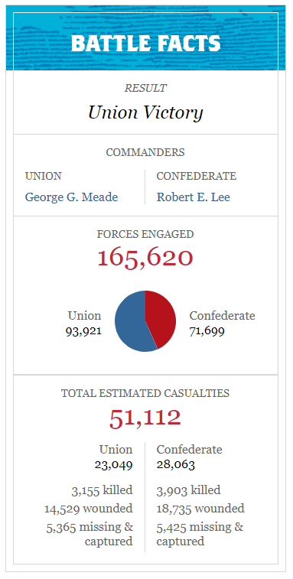
  - Who won the battle?

  - How many casualties (deaths/injuries) were there?

  - What do casualties include?

______________________
______________________
______________________

- What do you know about the Civil War already?

- The war started in 1861. The Battle of Gettysburg takes place in 1863. The war ends in 1865. Why might it be called the turning point of the war?

I think.3 the Be6attle of Gettysburg is called the turning point of the war because ____________
Nnnnnnn je______________________________________________________________________________________
______________________________________________________________________________________

Compelling Question:

After watching the virtual tour, what event/decision do you think was the most important of the battle? Why?

Day 1: https://www.loom.com/share/ca29d7d08e1c48b2a029736079553a75

Day 2: https://www.loom.com/share/c9b6c8f6d0374a7380a8a287cc472eba

Day 3: https://www.loom.com/share/f97b7070fede41158a62a67553322c7a

What event/decision do you think was the most important of the battle? Why?
Explain your thinking and reasoning by (pick one):
- writing a paragraph
- drawing a picture
- or creating a video

After the Virtual Tour

Take some time to explore the Gettysburg Battlefield on your own:
https://www.battlefields.org/visit/virtual-tours/gettysburg-360-virtual-tour

- What are three facts you learned?

___________________________________________________________________________
___________________________________________________________________________
___________________________________________________________________________

- What is something you’d still like to learn?

One thing I’m still curious about is…

-OR-

Choose one of the following tasks to complete!

  - Choose another Civil War battlefield on the website to explore: https://www.battlefields.org/visit/battlefields?gclid=EAIaIQobChMIoqLm2KSs6QIVpP_jBx0FawXPEAAYASAAEgKwnfD_BwE. Create your own video tour of this battle.

  - Choose another Civil War battlefield on the website to explore: https://www.battlefields.org/visit/battlefields?gclid=EAIaIQobChMIoqLm2KSs6QIVpP_jBx0FawXPEAAYASAAEgKwnfD_BwE. Create a travel brochure for a tourist visiting this battlefield.

-OR-

Think about the witness trees at Gettysburg. Write a story or a poem about what the tree saw during the battle.

