Chapter 21: The Indian Subcontinent

Indian Subcontinent: Political

What You Will Learn…
In this chapter you will learn about the physical geography of the Indian Subcontinent. You will also discover the history and culture of the region. Finally, you will learn about the countries of the Indian Subcontinent today.

Culture The people of the subcontinent represent the many cultures and religions of the region. |  | History India’s Taj Mahal was built during the Mughal Empire, one of many empires that ruled the Indian Subcontinent. |  | Geography The Indian Subcontinent is home to some of the world’s highest mountains, including Pakistan’s K2.

Section 1: Physical Geography

If YOU lived there…
You live in a small farming village in central India. Every year your father talks about the summer monsoons, winds that can bring heavy rains to the region. You know that too much rain can cause floods that may threaten your house and family. Too little rain could cause your crops to fail.
How do you feel about the monsoons?

BUILDING BACKGROUND Weather in the Indian Subcontinent, a region in southern Asia, is greatly affected by monsoon winds. Monsoons are just one of the many unique features of the physical geography of the Indian Subcontinent.

Physical Features
Locate Asia on a map of the world. Notice that the southernmost portion of Asia creates a triangular wedge of land that dips into the Indian Ocean. The piece of land jutting out from the rest of Asia is the Indian Subcontinent. A subcontinent is a large landmass that is smaller than a continent.
The Indian Subcontinent, also called South Asia, consists of seven countries—Bangladesh, Bhutan, India, Maldives, Nepal, Pakistan, and Sri Lanka. Together these countries make up one of the most unique geographic regions in the world. Soaring mountains, powerful rivers, and fertile plains are some of the region’s dominant features.

Mountains
Huge mountain ranges separate the Indian Subcontinent from the rest of Asia. The rugged Hindu Kush mountains in the northwest divide the subcontinent from Central Asia. For thousands of years, peoples from Asia and Europe have entered the Indian Subcontinent through mountain passes in the Hindu Kush.
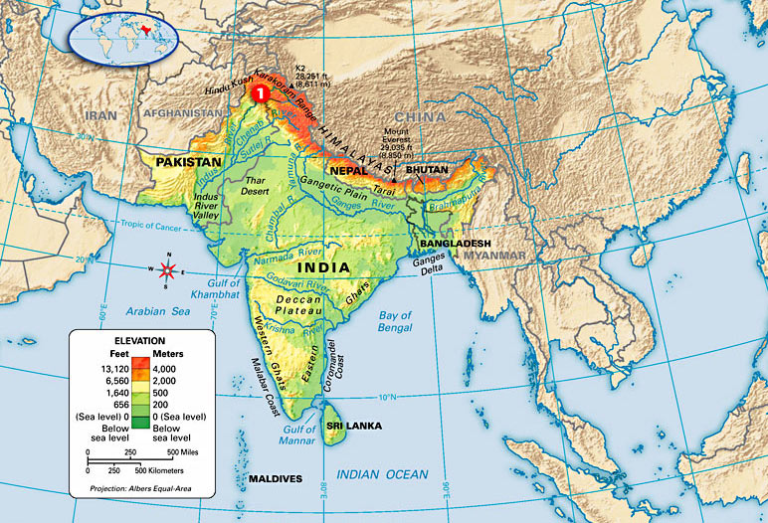
Two smaller mountain ranges stretch down India’s coasts. The Eastern and Western Ghats (GAWTS) are low mountains that separate India’s east and west coasts from the country’s interior.
Perhaps the most impressive physical features in the subcontinent, however, are the Himalayas. These enormous mountains stretch about 1,500 miles (2,415 km) along the northern border of the Indian Subcontinent. Formed by the collision of two massive tectonic plates, the Himalayas are home to the world’s highest mountains. On the border between Nepal and China is Mount Everest, the highest mountain on the planet. It measures some 29,035 feet (8,850 m). K2 in northern Pakistan is the world’s second highest peak.

Rivers and Plains
Deep in the Himalayas are the sources of some of Asia’s mightiest rivers. Two major river systems—the Ganges (GAN-jeez) and the Indus—originate in the Himalayas. Each carries massive amounts of water from the mountains’ melting snow and glaciers. For thousands of years, these rivers have flooded the surrounding land, leaving rich soil deposits and fertile plains.
India’s most important river is the Ganges. The Ganges River flows across northern India and into Bangladesh. There, the Ganges joins with other rivers and creates a huge delta. A delta is a landform at the mouth of a river created by sediment deposits. Along the length of the Ganges is a vast area of rich soil and fertile farmland. Known as the Ganges Plain, this region is India’s farming heartland.

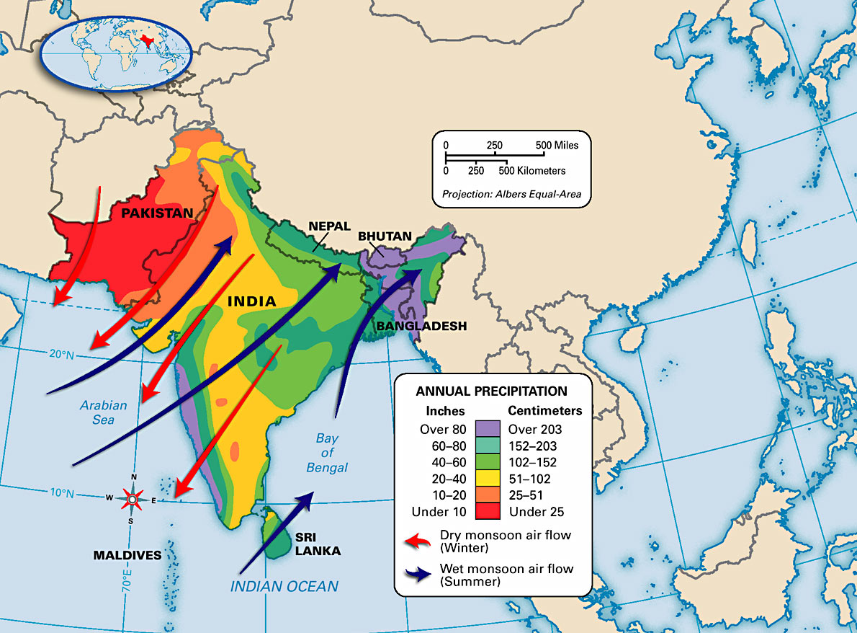
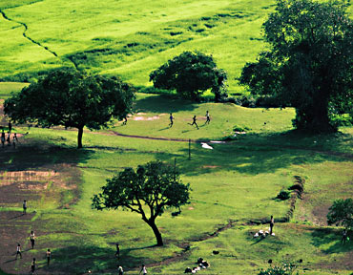 |  | 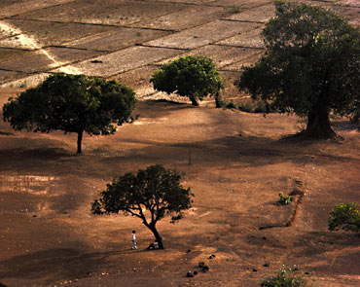
Summer monsoons often bring heavy rains and fertile growing conditions to many places in the Indian Subcontinent. |  | During the winter, monsoons change direction, bringing dry air from the north to the subcontinent. Little rain falls during this time of year.

Likewise, Pakistan’s Indus River also creates a fertile plain known as the Indus River Valley. This valley was once home to the earliest Indian civilizations. Today, it is Pakistan’s most densely populated region.
Other Features
Other geographic features are scattered throughout the subcontinent. South of the Ganges Plain, for example, is a large, hilly plateau called the Deccan. East of the Indus Valley is the Thar (TAHR), or Great Indian Desert. Marked by rolling sand dunes, parts of this desert receive as little as 4 inches (100 mm) of rain per year. Still another geographic region is the Tarai (tuh-RY) in southern Nepal. It has fertile farmland and tropical jungles.

Climates and Resources
Just as the physical features of the Indian Subcontinent differ, so do its climates and resources. A variety of climates and natural resources exist throughout the region.
Climate Regions
From the Himalayas’ snow-covered peaks to the dry Thar Desert, the climates of the Indian Subcontinent differ widely. In the Himalayas, a highland climate brings cool temperatures to much of Nepal and Bhutan. The plains south of the Himalayas have a humid subtropical climate. Hot, humid summers with plenty of rainfall are common in this important farming region.
Tropical climates dominate much of the subcontinent. The tropical savanna climate in central India and Sri Lanka keeps temperatures there warm all year long. This region experiences wet and dry seasons during the year. A humid tropical climate brings warm temperatures and heavy rains to parts of southwest India, Sri Lanka, Maldives, and Bangladesh.
The remainder of the subcontinent has dry climates. Desert and steppe climates extend throughout southern and western India and most of Pakistan.
Monsoons have a huge influence on the weather and climates in the subcontinent. Monsoons are seasonal winds that bring either moist or dry air to an area. From June to October, summer monsoons bring moist air up from the Indian Ocean, causing heavy rains. Flooding often accompanies these summer monsoons. In 2005, for example, the city of Mumbai (Bombay), India received some 37 inches (94 cm) of rain in just 24 hours. However, in winter the monsoons change direction, bringing dry air from the north. Because of this, little rain falls from November to January.

Natural Resources
A wide variety of resources are found on the Indian Subcontinent. Agricultural and mineral resources are the most plentiful.
Perhaps the most important resource is the region’s fertile soil. Farms produce many different crops, such as tea, rice, nuts, and jute, a plant used for making rope. Timber and livestock are also key resources in the subcontinent, particularly in Nepal and Bhutan.
The Indian Subcontinent also has an abundance of mineral resources. Large deposits of iron ore and coal are found in India. Pakistan has natural gas reserves, while Sri Lankans mine many gemstones.

Climate Regions
From the Himalayas’ snow-covered peaks to the dry Thar Desert, the climates of the Indian Subcontinent differ widely. In the Himalayas, a highland climate brings cool temperatures to much of Nepal and Bhutan. The plains south of the Himalayas have a humid subtropical climate. Hot, humid summers with plenty of rainfall are common in this important farming region.
Tropical climates dominate much of the subcontinent. The tropical savanna climate in central India and Sri Lanka keeps temperatures there warm all year long. This region experiences wet and dry seasons during the year. A humid tropical climate brings warm temperatures and heavy rains to parts of southwest India, Sri Lanka, Maldives, and Bangladesh.
The remainder of the subcontinent has dry climates. Desert and steppe climates extend throughout southern and western India and most of Pakistan.
Monsoons have a huge influence on the weather and climates in the subcontinent. Monsoons are seasonal winds that bring either moist or dry air to an area. From June to October, summer monsoons bring moist air up from the Indian Ocean, causing heavy rains. Flooding often accompanies these summer monsoons. In 2005, for example, the city of Mumbai (Bombay), India received some 37 inches (94 cm) of rain in just 24 hours. However, in winter the monsoons change direction, bringing dry air from the north. Because of this, little rain falls from November to January.

Natural Resources
A wide variety of resources are found on the Indian Subcontinent. Agricultural and mineral resources are the most plentiful.
Perhaps the most important resource is the region’s fertile soil. Farms produce many different crops, such as tea, rice, nuts, and jute, a plant used for making rope. Timber and livestock are also key resources in the subcontinent, particularly in Nepal and Bhutan.
The Indian Subcontinent also has an abundance of mineral resources. Large deposits of iron ore and coal are found in India. Pakistan has natural gas reserves, while Sri Lankans mine many gemstones.

Reading Check Summarizing What climates and resources are located in this region?

SUMMARY AND PREVIEW In this section you learned about the wide variety of physical features, climates, and resources in the Indian Subcontinent. Next, you will learn about the rich history and culture of this unique region.
Reviewing Ideas, Terms, and Places

1. Define: What is a subcontinent?

2. Make Inferences: Why do you think the Indus River Valley is so heavily populated?

3. Rank: Which physical features in the Indian Subcontinent would you most want to visit? Why?

4. Identify: What natural resources are found in the Indian Subcontinent?

5. Analyze: What are some of the benefits and drawbacks of monsoons?

