Section 3: India Today

If YOU lived there…
You live in Mumbai, India’s largest city. A major port, Mumbai is home to many industries, such as textiles and electronics. Museums and theaters offer entertainment. Every year, thousands of people flock to Mumbai in search of jobs or to enroll in its universities. The streets are crowded, and pollution is often heavy.
Do you enjoy living in Mumbai? Why or why no
BUILDING BACKGROUND India has undergone many changes since gaining its independence from Great Britain. Cities have grown dramatically, new businesses and industries have developed, and the population has exploded. India today faces many challenges.

Daily Life in India
More than 1 billion people live in India today. This huge population represents modern India’s many different ethnic groups, religions, and lifestyles. Despite these many differences, city life, village life, and religion all help unite the people of India.

Cities
Millions of Indians live in large, bustling cities. In fact, India’s two largest cities, Mumbai (Bombay) and Kolkata (Calcutta), are among the world’s most populous cities. Many people in Indian cities work in factories and offices. Some cities, like Bangalore and Mumbai, are home to universities, research centers, and high-tech businesses. Most city-dwellers, however, struggle to earn a living. Many people live in shacks made of scraps of wood or metal. They often have no plumbing and little clean water.

Villages
Most Indians still live in rural areas. Hundreds of thousands of villages are home to more than 70 percent of India’s population. Most villagers work as farmers and live with an extended family in simple homes. Only recently have paved roads and electricity reached many Indian villages.
Religion
In both cities and villages, religion plays a key role in Indian daily life. While most Indians practice Hinduism, many people follow several other religions such as Islam, Buddhism, and traditional religions. In addition, millions of Indians practice two native religions, Sikhism and Jainism.
Religious celebrations are an important part of Indian life today. One of India’s most popular festivals is Diwali, the festival of lights. Diwali celebrates Hindu, Sikh, and Jain beliefs.

Diwali: The Festival of Lights
Diwali, or the festival of lights, is one of the most important celebrations in India. A variety of activities on each of the five days of Diwali celebrate Hindu, Sikh, and Jain beliefs.
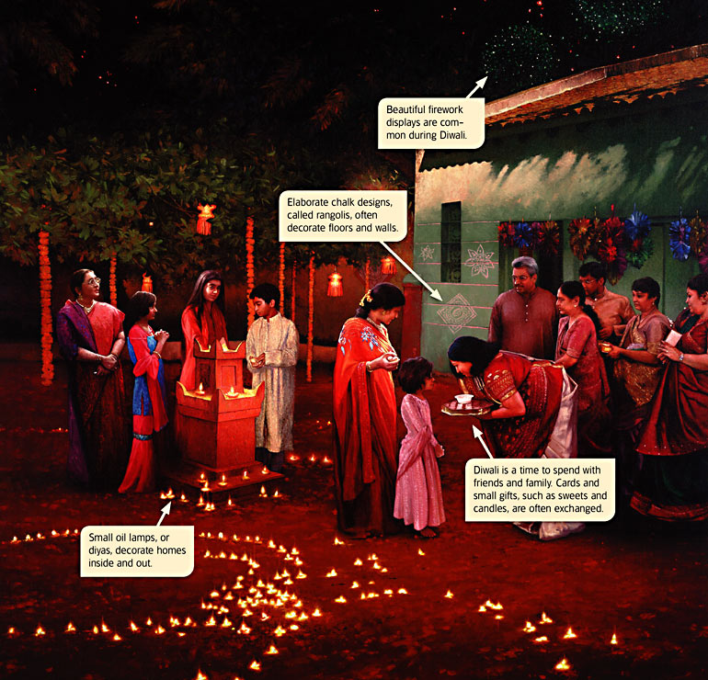

India’s Challenges
India has undergone drastic changes since gaining independence. Today the country faces several challenges, such as dealing with a growing population and managing its economic development.

Population
Its more than 1 billion people make India the world’s second most populous country. Only China has a larger population. India’s population has grown rapidly, doubling since 1947. This huge population growth places a strain on India’s environment and many of its resources, including food, housing, and schools.
India’s cities are particularly affected by the growing population. As the country’s population has grown, urbanization has taken place. Urbanization is the increase in the percentage of people who live in cities. Many millions of people have moved to India’s cities in search of jobs.

Government and Economy
Since India gained independence, its leaders have strengthened the government and economy.
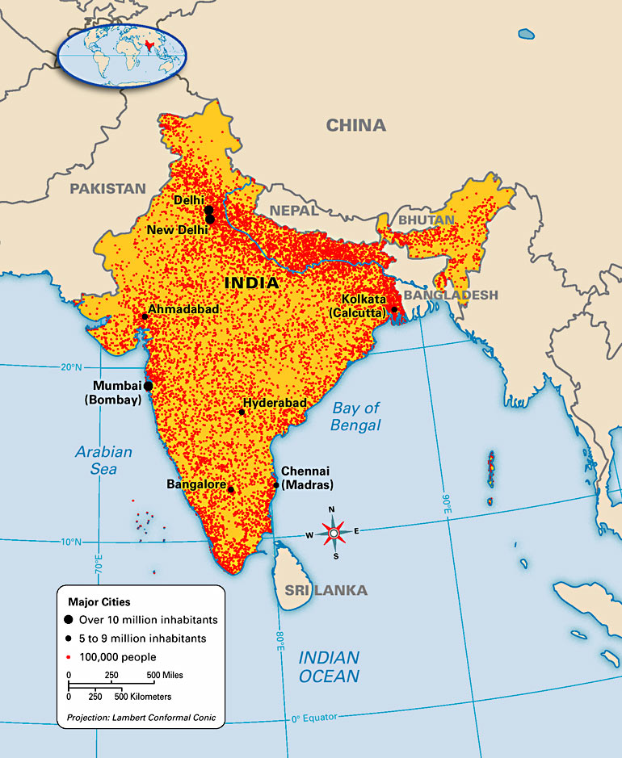

Today India is the world’s largest democracy and one of the strongest nations in Asia. The greatest challenges facing India's government are providing for a growing population and resolving conflicts with its neighbor, Pakistan. Both India and Pakistan have nuclear weapons.
India’s gross domestic product (GDP) places it among the world’s top 5 industrial countries. However, its per capita, or per person, GDP is only $3,300. As a result, millions of Indians live in poverty.
India’s government has taken steps to reduce poverty. In the 1960s and 1970s the green revolution, a program that encouraged farmers to adopt modern agricultural methods, helped farmers produce more food. Recently, the government has succeeded in attracting many hightech businesses to India.

Bollywood

One of India’s largest industries is its moviemaking industry. Much of India’s film industry is located in Mumbai (Bombay). Many people refer to the industry as Bollywood—a combination of Bombay and Hollywood. Bollywood produces more films every year than any other country. In 2003, for example, India produced 1,100 films—almost twice the number of films produced in the United States. In recent years, Bollywood films have become increasingly popular outside of India— particularly in the United Kingdom and the United States.
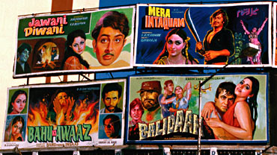

Reviewing Ideas, Terms, and Places
- Identify: What different religions are practiced in India today?

- Compare and Contrast: In what ways are Indian cities similar to cities in the United States? How are they different from U.S. cities?

- Elaborate: Why do you think that a majority of Indians live in villages?

- Predict: What effects might India’s growing population have on its resources and environment in the future?

