Chapter 21: Section 4
India’s Neighbors

If YOU lived there…
You live in the mountainous country of Bhutan. For many years Bhutan’s leaders kept the country isolated from outsiders. Recently, they have begun to allow more tourists to enter the country. Some of your neighbors believe that tourism will greatly benefit the country. Others think it could harm the environment.
How do you feel about tourism in Bhutan?
BUILDING BACKGROUND After years of isolation or control by Great Britain, the 1900s brought great changes to the countries on the Indian Subcontinent. Today these countries face rapid population growth and economic and environmental concerns.
Culture
Five countries—Pakistan, Bangladesh, Nepal, Bhutan, and Sri Lanka—share the subcontinent with India. Though they are neighbors, these countries have significantly different cultures.

People The cultures of the countries that border India reflect the customs of many ethnic groups. For example, the Sherpas, an ethnic group from the mountains of Nepal, often serve as guides through the Himalayas. Members of Bhutan’s largest ethnic group originally came from Tibet, a region in southern China. Many of Sri Lanka’s Tamil (TA-muhl) people came from India to work the country’s huge plantations.

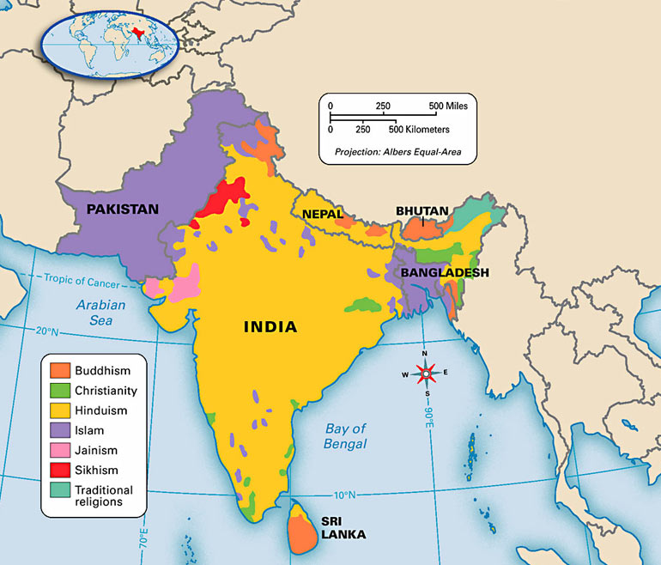
Religion As you can see on the map on the next page, a variety of religions exist on the Indian Subcontinent. Most countries, like India, have one major religion. In Pakistan and Bangladesh, for example, most people practice Islam and small portions of the population follow Hinduism, Christianity, and tribal religions. In Nepal, the dominant religion is Hinduism, although Buddhism is practiced in some parts of the country. Buddhism dominates both Bhutan and Sri Lanka.

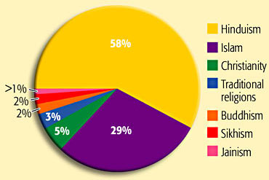
The Region Today
Like India, the other nations of the subcontinent face a variety of challenges. Two of the greatest challenges are population growth and poverty.

Pakistan
One of the greatest challenges Pakistan faces is the lack of government stability. Since its creation in 1947, Pakistan has suffered from rebellions and assassinations of government leaders. In 2001, General Pervez Musharraf came to power in a military coup.
Another challenge in Pakistan is rapid population growth. The country’s government struggles to manage resources and to reduce poverty. Some people fear that Pakistan’s large population and high levels of poverty could cause even more instability.
Relations with India are another important issue in Pakistan today. Since the partition in 1947, the two countries have clashed over the territory of Kashmir. Both India and Pakistan claim control of the region. Today Pakistan controls western Kashmir while India controls the east. Armed troops from both countries guard a “line of control” that divides Kashmir.
Since 2001 Pakistan has aided the United States in its war on terrorism. Pakistan’s military has arrested hundreds of terrorists and provided information about suspected terrorists. Despite this crackdown, however, many people believe that there are still terrorists within Pakistan’s borders.
Bangladesh
Bangladesh is a small country about the same size as the state of Wisconsin. Despite its small size, Bangladesh’s population is almost half the size of the U.S. population. As a result, it is one of the world’s most densely populated countries with some 2,850 people per square mile (1,055 per square km). The capital and largest city, Dhaka (DA-kuh), is home to over 12 million people. Overcrowding is not limited to urban areas, however. Rural areas are also densely populated.
Flooding is one of Bangladesh’s biggest challenges. Many circumstances cause these floods. The country’s many streams and rivers flood annually, often damaging farms and homes. Summer monsoons also cause flooding. For example, massive flooding in 2004 left more than 25 million people homeless. It also destroyed schools, farms, and roads throughout the country.
Nepal
The small kingdom of Nepal also faces many challenges today. Its population is growing rapidly. In fact, the population has more than doubled in the last 30 years. Kathmandu (kat-man-DOO), the nation’s capital and largest city, is troubled by overcrowding and poverty. Thousands have moved to Kathmandu in search of jobs and better opportunities. As a result of population growth and poor resources, Nepal is one of the world’s least-developed nations.
Nepal also faces environmental threats. As the population grows, more and more land is needed to grow enough food. To meet this need, farmers clear forests to create more farmland. This deforestation causes soil erosion and harms the wildlife in the region. Nepal’s many tourists add to the problem as they use valuable resources and leave behind trash.

Bhutan
Bhutan is a small mountain kingdom that lies in the Himalayas between India and China. Because of the rugged mountains, Bhutan has been isolated throughout much of its history. This isolation limited outside influences until the 1900s, when Bhutan’s king established ties first with Great Britain and later with India. By the mid-1900s Bhutan had ended its long isolation. Efforts to modernize Bhutan resulted in the construction of new roads, schools, and hospitals.
Today Bhutan continues to develop economically. Most Bhutanese earn a living as farmers, growing rice, potatoes, and corn.
Some raise livestock like yaks, pigs, and horses. Another important industry is tourism. The government, however, limits the number of visitors to Bhutan to protect Bhutan’s environment and way of life.

Sri Lanka
Sri Lanka is a large island country located some 20 miles (32 km) off India’s southeast coast. As a result of its close location, India has greatly influenced Sri Lanka. In fact, Sri Lanka’s two largest ethnic groups—the Tamil and the Sinhalese (sing-guh-LEEZ)— are descended from Indian settlers.
Conflicts between the Sinhalese and the Tamil divide Sri Lanka today. The Tamil minority has fought for years to create a separate state. Despite a 2002 cease-fire, violence between the two sides continues to disrupt the island nation.
Parts of Sri Lanka were devastated by the 2004 tsunami in the Indian Ocean. Thousands of Sri Lankans were killed, and more than 500,000 people were left homeless. The tsunami also damaged Sri Lanka’s fishing and agricultural industries, which are still struggling to rebuild.

Reviewing Ideas, Terms, and Places
 | 1. What are the major religions of the Indian Subcontinent?
 | b. Summarize What cultural differences exist among India’s neighbors?
 | c. Elaborate Why do you think there are so many different religions in this region?
2 | a. Identify What is the capital of Nepal?
 | b. Compare and Contrast In what ways are the countries of this region similar and different?
 | c. Predict How might conflict over Kashmir cause problems in the future?

